Newsletter 18/07/21 – THE SEVENTH SUNDAY AFTER TRINITY

Our Church Building is COVID-secure, so you can either attend worship physically or worship with us at home on Facebook.

Sundays:
10.30am in Church for COVID-secure Communion
12 Noon for live-streamed midday worship on our Facebook Page

Wednesdays:
6.30pm in Church for Mid-Week Praise (recording posted on Facebook later)

To join us on Facebook, follow this link:
https://www.facebook.com/ChristChurchAinsworth

Bible Reading for Sunday 18th July: Mark 6.30-34,53-56
If you missed any of our livestreamed services, some of them can be found on our website https://www.ainsworthparish.org.uk/online-worship.html or our YouTube Channel
https://www.youtube.com/channel/UC1kRCPBIymPoDSyhH9CZYrw The Prayer Book Society lists some churches livestreaming BCP services: https://www.pbs.org.uk/churches-and-services/-1

Planning to attend our church building for worship? The following COVID-19 Secure restrictions apply (updated 21/5/21):
- Unless you are legally exempt, you must wear a facemask.
- Our seating capacity is normally limited to 28 downstairs but can be increased slightly when members of the same household/bubble attend together. There is also limited capacity (15) upstairs.
- Services are relatively short.
- Everyone must gel their hands as they enter the building.
- There is a collection plate on the font, but this will not be passed around.
- Worshippers are expected to remain 2m socially distant from each other, unless from the same household/linked household/bubble/group of 6. This means sitting down promptly (where the paper is on the pew) and no gathering in the aisle or immediately outside the main door for a chat.
- When worshippers enter, they must sit in the next available pew, filling from the front and from the wall, taking care not to touch any part of the pew as you move along. There must be no heading for that favourite pew!
- Everyone (except the presiding priest) will remain seated throughout each service. Unfortunately, this means any children attending must also remain seated throughout the service.
- There is no singing.
- A PowerPoint version of the order of service is projected in church.
- A Test & Trace QR Code is displayed at the entrance for those worshippers who have downloaded the NHS T&T app. Others are asked to complete a registration form each week. The forms will be destroyed after three weeks. A GDPR compliant privacy notice is posted inside church.
- We leave from the rear pew first.
- The toilet is for emergencies only, and anyone using it is expected to spray disinfectant on all surfaces they have touched.
Whether you attend worship in church with others, or prefer to join with us on Facebook, is entirely your decision. Our responsibility is to ensure you have the choice.
Anyone showing symptoms of COVID-19 (a new continuous cough, a high temperature or a loss of, or change in, their normal sense of taste or smell) should not join us in church due to the risk to others; they should self-isolate at home immediately and arrange a PCR test.

New or Amended Notices:

COVID Restrictions: The Government has announced that the COVID restrictions will be relaxed from 19th July (to the relief of some and the anxiety of others). It is expected that some restrictions will remain in place but, until updated guidance is received from the Government and the Church of England, it is unclear precisely what those restrictions will be.

Join us for Christianity Explored! CE is a seven-session course that gives you the time and space to think about the big questions of life, discover who Jesus is, why he came and what it means to follow him.

The course is suitable everyone, whether exploring Christianity or seeking a refresher on the Christian message. The structure of each session is simple: a short Bible study, a video, and a discussion. We begin on 7th September (7.30pm on Zoom), so sign up and invite a friend. Expressions of interest to Revd Dave.

Worship at Home: There were no technical hitches affecting worshippers in the UK last Sunday, but anyone joining Worship at Home from overseas on a ‘catch up’ basis (i.e., after we have finished livestreaming) will have found one of the hymns muted. In recent weeks, UK worshippers have discovered this too. Unfortunately, despite our holding a Livestreaming Copyright Licence, the algorithms employed by Facebook sometimes identify non-existent copyright breaches. YouTube have a different policy and an unmuted version can always be found on the parish YouTube Channel. This does not affect the live webcast.

Rainbows: Heartfelt thanks from all at Christ Church go out to our Rainbow leaders who, after doing a sterling job over many years, have decided to step down. This means that, unless new leaders can be found, there will no longer be a Rainbow unit in Ainsworth. It would be sad if that were to happen, so volunteers are needed urgently. If you are thinking of volunteering and want to know more, you can register your interest on the Girlguiding website:
https://www.girlguiding.org.uk/get-involved/become-a-volunteer/register-your-interest/

Previous Notices:
Easy Fundraising
If you’re planning to go on holiday, did you know you can raise FREE funds using easyfundraising for Ainsworth Parish Church - Bolton when you book? Whether you’re booking your 2021 summer holiday, or a short-getaway, if you book via easyfundraising on TUI, Booking.com, Expedia, First Choice, Hotels.com, Cottages.com, HomeAway easyJet holidays, PurpleParking plus 250+ other well-known travel companies, you’ll raise free funds for us at no extra cost to you. You can also raise money by booking your airport parking, transfers and even your foreign currency and travel insurance! Find out more at:
https://www.easyfundraising.org.uk/raise-when-you-getaway?utm_campaign=raise-more&utm_medium=email&utm_content=rm-trvl21-e1
Bible Reading Rota: Although the relaxation of the remaining COVID restrictions is delayed, it is still necessary to plan for a gradual return to something like normality. Therefore, it would be helpful to reconstruct the rota of volunteers willing to read the Bible during services. Initially, until the post-pandemic pattern of worship has emerged, we are seeking readers for the 10.30am morning service in church and the 12 noon ‘Worship at Home’ livestream only. Those on the midday rota will need to video themselves reading beforehand, email the recording to Revd Dave in good time for inclusion in the livestream. We are compiling the rota from scratch, making no assumptions about whether those on the pre-pandemic list wish to continue. So, if interested, whether you have read in church before or not, please email Revd Dave stating the service(s) during which you wish to read.

Church Building and Churchyard: If you have a bit of time to spare and would like to help your Church in a practical way, then please join either the Churchyard Team (come to the Churchyard on Wednesdays from 9:30am) or the Pew Polishers (contact Jane Lord, 0161 764 1551) or both.

Collection: if you normally make your weekly offering via the envelope scheme or by placing cash on the collection plate but feel unable to return to worship in church for now, please consider setting up a standing order or making a bank transfer (contact Revd Dave). Otherwise, if you can do so, please arrange for someone to pop your offering through the Vicarage letter box. (NB setting up a standing order or making a bank transfer does not involve giving us your bank details.)

Building Officer: we need a Building Officer. This is about arranging and overseeing (but not necessarily undertaking personally) the care and maintenance of our church building and its contents. Examples range from simple tasks (e.g., arranging for the gutters to be cleared or the fire extinguishers to be tested annually), through to projects such as our new sound system and overseeing the next phase of our building maintenance project (e.g., completion of the repointing external walls, redecoration etc.). This sometimes includes obtaining necessary permissions from the Diocese, and liaising with volunteers, contractors, and our Parish Architect. This could be undertaken as a ‘job share’. Again, if you feel you can help, contact Revd Dave for a chat.

Porch Boxes: During lockdown it is not possible to receive donations for Porch Boxes in Church. However, if you shop at any of the following, they have somewhere to receive donations: ASDA (Radcliffe; Pilsworth & Bury); MORRISONS (Whitefield & Ramsbottom); TESCO (Bury & Ramsbottom) OR we can still support Porch Boxes through a donation: A cheque made payable to “The Porch” sent to Michael Perrin, 14 Kenmore Avenue Bury BL8 2DY or Bank transfer to Account number 81643089 sort code 09-0155 account name The Porch or Online https://porchboxes.wordpress.com/

Please hold in your prayers:
Our Confirmation Candidates who are being Confirmed today (18th): Erin, Hannah, Imogen, Isabella, Lyra, and Ralphie. Also for Harry, Jacob, Jess, and Lily-Mae who, sadly, cannot be Confirmed at this time because their class is required to self-isolate.
The sick: all who are ill, especially for: Barbara Aspin, Alan Clifford, Betty Lawrence, Nora Tudge, Deborah Sandercock-Pickles, Margaret Turner, Stella Burkey and Louise Singleton.
The bereaved: All who have lost loved ones. May they find healing, peace, strength, and courage to face the future.

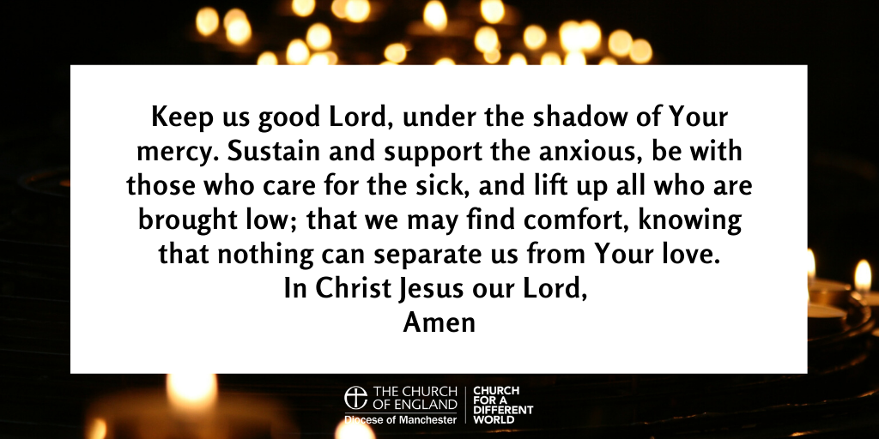

“The prayer of the righteous is powerful and effective.” (James 5:16)

