Newsletter 25/07/21 – THE EIGHTH SUNDAY AFTER TRINITY

Our Church Building is COVID-secure, so you can either attend worship physically or worship with us at home on Facebook.

Sundays:
10.30am in Church for COVID-secure Communion
12 Noon for live-streamed midday worship on our Facebook Page

Wednesdays:
6.30pm in Church for Mid-Week Praise

To join us on Facebook, follow this link:
https://www.facebook.com/ChristChurchAinsworth

Bible Reading for Sunday 25th July: John 6.1-21
If you missed any of our livestreamed services, some of them can be found on our website https://ainsworthparish.org.uk/online-worship.html or our YouTube Channel
https://www.youtube.com/channel/UC1kRCPBIymPoDSyhH9CZYrw The Prayer Book Society lists some churches livestreaming BCP services: https://www.pbs.org.uk/churches-and-services/-1

Planning to attend our church building for worship? The following COVID-19 Secure restrictions apply (updated 19/7/21):
For your comfort we are operating three zones, offering different levels of security. The Zone you choose to sit in depends upon YOUR assessment of personal risk. For example, if you have few concerns and are not bothered about being pinged by the NHS Test & Trace app, then sit in Zone 1. If you are clinically vulnerable, you might prefer Zone 3.

Zone 1 (right hand side of the aisle):
- You are advised to wear a facemask, but it is your decision.
- There is no requirement to remain socially distant.

Zone 2 (left hand of the aisle – 1m⁺ social distance):
- Please wear a facemask
- Please sit in the designated pews, sitting in the space indicated by arrows.

Zone 3 (upstairs left & centre pews and the back Choir pews - 2m social distance)
- Please wear a facemask
- Please sit in the designated pews, sitting in the space indicated by arrows.

Singing: From 19/7/21 we shall begin singing again in church. There is no need to join in, but if you do, please wear a mask if you plan to sing loudly!

Communion:
- Clergy will continue to preside in a COVID Secure manner.
- For now, we will not be sharing the Common Cup. Instead, after gelling their hands, clergy will carefully dip your wafer in the wine before safely dropping it in your hands.
- Zone 1 – we will distribute to you from the Communion Rail. Please mask and line up as directed.
- Zones 2 & 3 – remain seated, clergy will come to you.

General:
- We will leave the doors open to enhance air circulation.
- Please gel your hands as you enter and leave the building.
- There is a collection plate on the font, but this will not be passed around.
- Although we shall now stand at various points in the service (e.g., for the Gospel), you are at liberty to remain seated throughout if you wish.
- To avoid handling service books, a PowerPoint version of the order of service is projected in church. However, if you struggle with this, there are a few printed orders of service available on request (please take them home with you afterwards).
- If you are in Zone 1, please allow those in Zones 2 and 3 to exit first as they need to maintain social distance.

Whether you attend worship in church with others, or prefer to join with us on Facebook, is entirely your decision. Our responsibility is to ensure you have the choice.
Anyone showing symptoms of COVID-19 (a new continuous cough, a high temperature or a loss of, or change in, their normal sense of taste or smell) should not join us in church due to the risk to others; they should self-isolate at home immediately and arrange a PCR test. Likewise, please stay at home if you have been pinged by Test & Trace.

New or Amended Notices:

Christianity Explored is a seven-session course that gives you the time and space to think about the big questions of life, discover who Jesus is, why he came and what it means to follow him. The course is suitable everyone, whether exploring Christianity or seeking a refresher on the Christian message. The structure of each session is simple: a short Bible study, a video, and a discussion. We begin on 7th September (7.30pm on Zoom), so sign up and invite a friend. Expressions of interest to Revd Dave.

Foundations for Ministry is a stimulating course open to anyone active in church life who feels some sense of vocation or calling to Christian ministry, and needs some time and space to unpack what this might mean and look like. The course begins in September. Further details can be found here: Diocese of Manchester | Foundations for Ministry (anglican.org)

Building Officer: we still need a Building Officer. This is about arranging and overseeing (but not necessarily undertaking personally) the care and maintenance of our church building and its contents. Examples range from simple tasks (e.g., arranging for the gutters to be cleared or the fire extinguishers to be tested annually), through to projects such as our new sound system and overseeing the next phase of our building maintenance project (e.g., completion of the repointing external walls, redecoration etc.). This sometimes includes obtaining necessary permissions from the Diocese, and liaising with volunteers, contractors, and our Parish Architect. This could be undertaken as a ‘job share’. If you feel you can help, contact Revd Dave for a chat.

Easyfundraising - Did you know that you can raise BIG donations for Ainsworth Parish Church - Bolton when you organise your household bills? Whether you’re looking to switch your mobile phone, broadband or car insurance, you can save and raise a donation at the same time. Raise donations up to £40 with Vodafone, £15 with Uswitch and many more when you shop via #easyfundraising. Simply follow the link to check out the latest deals:
http://efraising.org/kRE2ieDEZX

Previous Notices:
Rainbows: Heartfelt thanks from all at Christ Church go out to our Rainbow leaders who, after doing a sterling job over many years, have decided to step down. This means that, unless new leaders can be found, there will no longer be a Rainbow unit in Ainsworth. It would be sad if that were to happen, so volunteers are needed urgently. If you are thinking of volunteering and want to know more, you can register your interest on the Girlguiding website:
https://www.girlguiding.org.uk/get-involved/become-a-volunteer/register-your-interest/
Bible Reading Rota: Although the relaxation of the remaining COVID restrictions is delayed, it is still necessary to plan for a gradual return to something like normality. Therefore, it would be helpful to reconstruct the rota of volunteers willing to read the Bible during services. Initially, until the post-pandemic pattern of worship has emerged, we are seeking readers for the 10.30am morning service in church and the 12 noon ‘Worship at Home’ livestream only. Those on the midday rota will need to video themselves reading beforehand, email the recording to Revd Dave in good time for inclusion in the livestream. We are compiling the rota from scratch, making no assumptions about whether those on the pre-pandemic list wish to continue. So, if interested, whether you have read in church before or not, please email Revd Dave stating the service(s) during which you wish to read.
Church Building and Churchyard: If you have a bit of time to spare and would like to help your Church in a practical way, please join the Churchyard Team (come to the Churchyard on Wednesdays from 9:30am) or the Pew Polishers (contact Jane Lord, 0161764 1551) or both.
Collection: if you normally make your weekly offering via the envelope scheme or by placing cash on the collection plate but feel unable to return to worship in church for now, please consider setting up a standing order or making a bank transfer (contact Revd Dave). Otherwise, if you can do so, please arrange for someone to pop your offering through the Vicarage letter box. (NB setting up a standing order or making a bank transfer does not involve giving us your bank details.)
Porch Boxes: During lockdown it is not possible to receive donations for Porch Boxes in Church. However, if you shop at any of the following, they have somewhere to receive donations: ASDA (Radcliffe; Pilsworth & Bury); MORRISONS (Whitefield & Ramsbottom); TESCO (Bury & Ramsbottom) OR we can still support Porch Boxes through a donation: A cheque made payable to “The Porch” sent to Michael Perrin, 14 Kenmore Avenue Bury BL8 2DY or Bank transfer to Account number 81643089 sort code 09-0155 account name The Porch or Online https://porchboxes.wordpress.com/

Please hold in your prayers:
The sick: all who are ill, especially for: Barbara Aspin, Alan Clifford, Betty Lawrence, Nora Tudge, Deborah Sandercock-Pickles, Margaret Turner, Stella Burkey and Louise Singleton.
The bereaved: All who have lost loved ones. May they find healing, peace, strength, and courage to face the future.

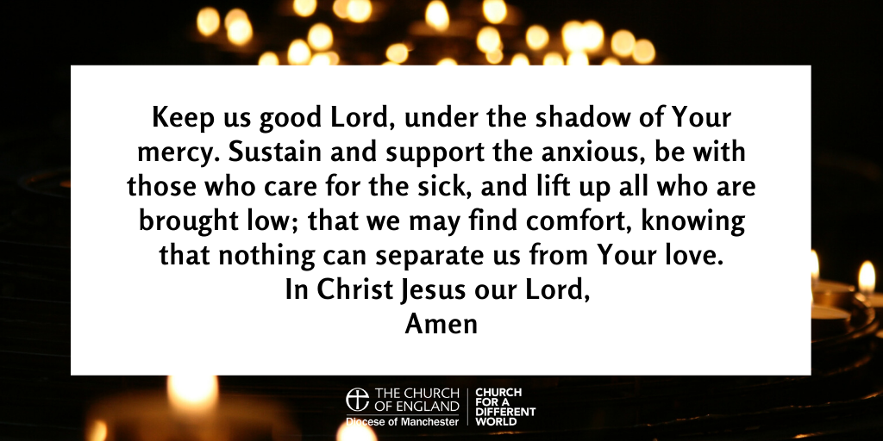

“The prayer of the righteous is powerful and effective.” (James 5:16)

