Newsletter 19/09/21 – THE SIXTEENTH SUNDAY AFTER TRINITY

Our Church Building is COVID-secure, so you can either attend worship physically or worship with us at home on Facebook.

Sundays:
10.30am in Church for COVID-secure Communion
12 Noon for live-streamed midday worship on our Facebook Page

Wednesdays:
6.30pm in Church for Mid-Week Praise

To join us on Facebook, follow this link:
https://www.facebook.com/ChristChurchAinsworth

Bible Readings for Sunday 12th September: James 3:13-4:3 & 4:7-8 (DH); Mark 9.30-37
If you missed any of our livestreamed services, some of them can be found on our website https://ainsworthparish.org.uk/online-worship.html or our YouTube Channel
https://www.youtube.com/channel/UC1kRCPBIymPoDSyhH9CZYrw The Prayer Book Society lists some churches livestreaming BCP services: https://www.pbs.org.uk/churches-and-services/-1

Planning to attend our church building for worship? The following COVID-19 Secure restrictions apply (updated 15/8/21):

For your comfort we are operating three zones, offering different levels of security. The Zone you choose to sit in depends upon YOUR assessment of personal risk. For example, if you have few concerns and are not bothered about being pinged by the NHS Test & Trace app, then sit in Zone 1. If you are clinically vulnerable, you might prefer Zone 3.

Zone 1 (right hand side of the aisle and first 4 rows at the front on the left):
- You are advised to wear a facemask, but it is your decision.
- There is no requirement to remain socially distant.

Zone 2 (remaining pews on left hand side of the aisle – 1m⁺ social distance):
- Please wear a facemask
- Please sit in the designated pews, sitting in the space indicated by arrows.

Zone 3 (upstairs left & centre pews and the back Choir pews - 2m⁺ social distance)
- Please wear a facemask
- Please sit in the designated pews, sitting in the space indicated by arrows.

Singing: We now sing in church (Hymns and The Gloria). There is no need to join in and, if you wish, you may wear a mask when singing

Communion:
- Clergy will continue to preside in a COVID Secure manner.
- For now, we will not be sharing the Common Cup. Instead, after gelling their hands, clergy will carefully dip your wafer in the wine before safely dropping it in your hands (this is known as Simultaneous Communion).
- Zone 1 – we will distribute to you from the Communion Rail. Please mask and line up as directed.
- Zones 2 & 3 – please remain seated, clergy will come to you.

General:
- We will leave the doors open to enhance air circulation.
- Please gel your hands as you enter and leave the building.
- There is a collection plate on the font, but this will not be passed around.
- Although we shall now stand at various points in the service (e.g., for the Gospel), you are at liberty to remain seated throughout if you wish.
- To avoid handling service books, a PowerPoint version of the order of service is projected in church. However, if you struggle with this, there are a few printed orders of service available on request (please take them home with you afterwards).
- If you are in Zone 1, please allow those in Zones 2 and 3 to exit first as they wish to maintain social distance.

Whether you attend worship in church with others, or prefer to join with us on Facebook, is entirely your decision. Our responsibility is to ensure you have the choice.
Anyone showing symptoms of COVID-19 (a new continuous cough, a high temperature or a loss of, or change in, their normal sense of taste or smell) should not join us in church due to the risk to others; they should self-isolate at home immediately and arrange a PCR test. Likewise, please stay at home if you have been pinged by Test & Trace.

New or Amended Notices:

Refreshments in Church next Sunday after the 10:30 service. Please stay for a chat, a drink, and a cake if you can.

MacMillan Coffee Morning. We are hosting a Coffee Morning this Friday (24th September) from 10:30am to 12 noon in the Church Hall. If you can bake a cake, you can bring it to the Church on Wednesday (22nd) from 9:30 to 10:30; to the vicarage on the Thursday (23rd) from 5:30 to 6:30pm, or to the hall on the day (after 9:00am but before 10:00 if possible). If you are unable to attend, you can still donate! (for online donations the link is
https://thyg.uk/BUU004777663 )

Scouts are also hosting their MacMillan Coffee Evening the same day from 7:30pm to 9:30pm so please come along to support these. They can provide transport to the evening event for anyone needing it (email Stacey at group.ainsworth@praws.gmnscouts.org.uk ).

Iron Man: If you plan to attend our 10.30am service next Sunday (25th) and are coming from the direction of Breightmet or Harwood, you may need to find an alternative route to and from church. Part of the Iron Man circuit runs through Breightmet, along Deepdale Road, Red Lane, and Bury Old Road, before turning left onto Arthur Lane, then right onto Roading Brook Road. Alternatively, join us at 12 noon for the Livestream.

Private Prayer: As we return to normal, we are hoping to open our Church once again on Wednesday afternoons for private prayer. To do this, we need volunteers to form a church sitting rota. Please email Revd Dave if interested.
BCP Services: Harvest (10th October) will be a Parade service, so space could be tight for those wishing to sit socially distanced from others at the 10.30am service. Therefore, we are taking the opportunity to hold a BCP Communion service on the same day, either at 8am or 6.30pm. The time will be determined by the majority preferences of those likely to attend. If you are likely to be present at the BCP service, please email Revd Dave stating whether you prefer 8am, 6.30pm, or will attend at either time. When the time is right, this will also help us determine the feasibility of reintroducing a regular 8am or 6.30pm BCP service.

Previous Notices:

Mission Communities: Bishop David believes that forming Mission Communities is the right way forward for the Diocese and expects that formal groupings will be determined by the end of November. Mission Communities will then begin to come together gradually over the next five years. Further information about the proposals (including a video) can be found here: Diocese of Manchester | What will mission communities look like? (anglican.org) Here is a link to the PCCs response to the initial proposals issued by the Diocese in October 2020:
https://1drv.ms/b/s!Aurx6pWvMgOaiYg8lsCIOjmBIbrsdA?e=IbvaFt . Sadly, in common with the experience of other parishes, some of our questions remain unanswered!

At its most basic, a Mission Community is a group of parishes collaborating in mission. This is common sense so, before the pandemic, this is something we had begun to do with St Andrew’s Radcliffe and Christ Church Walshaw. Each of our three parishes is distinct in terms of worship style and tradition, and the clergy involved aim to keep it that way. Therefore, our vision has always been to collaborate in such a way that would preserve the independence and distinctiveness of each of our parishes. The clergy from each parish would like this relationship to continue and develop further. Indeed, more recently, Christ’s Church Harwood have expressed an interest in working with our small group on the same terms.

The initial proposals published by the Diocese were light on detail, particularly around governance. It is expected that each Mission Community will be different, and a more recent paper sets out a range of possibilities. At one extreme, parishes could merge to form a single parish which, given the loss of independence, is unlikely to be acceptable to this parish and, for that matter, our neighbours. At the other end of the spectrum, parishes simply collaborate in mission, with the clergy from each parish supporting one another, which is more like it.

Understandably, in the light of recent press comments about increasing centralisation within the Church of England, there is a degree of apprehension within some parishes about whether Mission Communities are part of this drift. Indeed, it is possible to discern a centralising drift within the documentation published by the Diocese. Local clergy share these concerns and, whatever the future holds, fully support the desirability of preserving local style and traditions.

'Revd Dave would love to hear your views on this.

Parade Service: the first post-pandemic Parade service will be on Sunday 10th October (i.e., Harvest).

Bible Reading Rota: we have begun reading the Epistle at the 10.30am service on Sundays and, hopefully, will begin reading the set Old Testament passage soon. It would be wonderful if we could re-establish a Bible reading rota for the service as part of a wider return to normality. We are also seeking volunteers to read during ‘Worship at Home’ (the 12-noon livestreamed service). Please let Revd Dave know if you would like to join the rota. Those on the midday rota will need to video themselves reading beforehand, email the recording to Revd Dave in good time for inclusion in the livestream. We are compiling the rota from scratch, making no assumptions about whether those on the pre-pandemic list wish to continue. So, if interested, whether you have read in church before or not, please email Revd Dave stating the service(s) during which you wish to read.

Building Officer: we really do need a Building Officer to take responsibility for arranging and overseeing (but not necessarily undertaking personally) the care and maintenance of our church building and its contents. Examples range from simple tasks (e.g., minor repairs, arranging for the gutters to be cleared or the fire extinguishers to be tested annually), through to projects such as our new sound system and overseeing the next phase of our building maintenance project (e.g., completion of the repointing external walls, redecoration etc.). This sometimes includes obtaining necessary permissions from the Diocese, and liaising with volunteers, contractors, and our Parish Architect. This could be undertaken as a ‘job share’. If you feel you can help, contact Revd Dave for a chat.

Collection: if you normally make your weekly offering via the envelope scheme or by placing cash on the collection plate but feel unable to return to worship in church for now, please consider setting up a standing order or making a bank transfer (contact Revd Dave). Otherwise, if you can do so, please arrange for someone to pop your offering through the Vicarage letter box. (NB setting up a standing order or making a bank transfer does not involve giving us your bank details.)

Easyfundraising - Did you know that you can raise BIG donations for Ainsworth Parish Church - Bolton when you organise your household bills? Whether you’re looking to switch your mobile phone, broadband or car insurance, you can save and raise a donation at the same time. Raise donations up to £40 with Vodafone, £15 with Uswitch and many more when you shop via #easyfundraising. Simply follow the link to check out the latest deals:
http://efraising.org/kRE2ieDEZX

Porch Boxes: During lockdown it is not possible to receive donations for Porch Boxes in Church. However, if you shop at any of the following, they have somewhere to receive donations: ASDA (Radcliffe; Pilsworth & Bury); MORRISONS (Whitefield & Ramsbottom); TESCO (Bury & Ramsbottom) OR we can still support Porch Boxes through a donation: A cheque made payable to “The Porch” sent to Michael Perrin, 14 Kenmore Avenue Bury BL8 2DY or Bank transfer to Account number 81643089 sort code 09-0155 account name The Porch or Online https://porchboxes.wordpress.com/

Please hold in your prayers:

The sick: all who are ill, especially for: Barbara Aspin, Alan Clifford, Betty Lawrence, Nora Tudge, Deborah Sandercock-Pickles, Margaret Turner, Stella Burkey and Louise Singleton.

The bereaved: All who have lost loved ones, especially the family and friends of Barbara Kowalski and Ann Jennings. May they find healing, peace, strength, and courage to face the future.
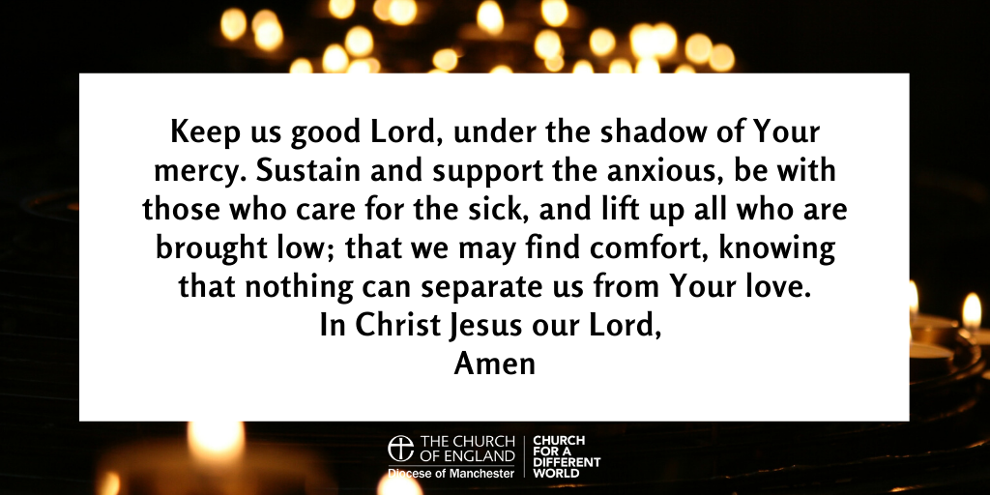

“The prayer of the righteous is powerful and effective.” (James 5:16)

